**Java PROGRAMMING LAB BCA-DS-402**

Manav Rachna International Institute of Research and Studies School of Computer Applications

**Department of Computer Applications**

|  |  |
| --- | --- |
| **Submitted By** | |
| **Student Name** | **Yash Raj Yadav** |
| **Roll No** | **23/SCA/BCA(AI&ML)/047** |
| **Program** | **Bachelor of Computer Applications** |
| **Semester** | **4** |
| **Section/Group** | **4C** |
| **Department** | **Computer Applications** |
| **Batch** | **2023-26** |
|  | |
| **Submitted To** | |
| **Faculty Name** | **Mrs. Priyanka Sharma** |

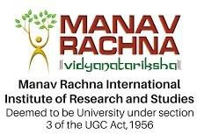**SCHOOL OF COMPUTER APPLICATIONS**

|  |  |  |
| --- | --- | --- |
| **S.No** | **Program name** | **date** |
|  | **LAB SESSION 1** |  |
| **1.** | **Write java program to print hello world** |  |
| **2.** | **Java Program to take input from user and print the sum**  **of two numbers** |  |
| **3.** | **Create a java program to check whether a number entered by user is even or odd** |  |
| **4.** | **Create a java program to print the average and sum of 5**  **numbers entered by user.** |  |
| **5.** | **Program to calculate the factorial of a number** |  |
| **6.** | **Program to print Fibonacci series up to n terms** |  |
|  | **LAB SESSION 2** |  |
| **1.** | **Program to reverse a number** |  |
| **2.** | **Write a program to find the average and sum of the N**  **numbers using Command line argument.** |  |
| **3.** | **Program to check if a number is a palindrome** |  |
| **4.** | **Program for a simple calculator** |  |
| **5.** | **Program to check if a number is prime** |  |
| **6.** | **Program to check if a number is an Armstrong number** |  |
|  | **LAB SESSION 3** |  |
| **1.** | **Print Multiplication Table** |  |
| **2.** | **Calculate Sum and Average of Array Elements** |  |
| **3.** | **Reverse a String** |  |
| **4.** | **Find Factorial of a Number Using Recursion** |  |
| **5.** | **Sort an Array in Ascending Order** |  |
|  | **LAB SESSION 4** |  |
| **1.** | **Check Palindrome for a String** |  |
| **2.** | **Count Vowels and Consonants in a String** |  |
| **3.** | **Implement a Simple Banking System** |  |
| **4.** | **Write a program to demonstrate type casting.** |  |
| **5.** | **Write a program to generate prime numbers between 1 & given number** |  |
|  | **LAB SESSION 5** |  |
| **1** | **Program to Demonstrate a Simple Class with Methods** |  |
| **2** | **Program for Class with Parameterized Constructor** |  |
| **3** | **Program to Find the Area of a Rectangle Using Methods** |  |
| **4** | **Program for Bank Account Class with Deposit and Withdraw Methods** |  |
| **5** | **Program to Demonstrate Method Overloading** |  |
|  | **LAB SESSION 6** |  |
| **1** | **Program to Demonstrate Static Methods** |  |
| **2** | **Program to Demonstrate Method Overriding** |  |
| **3** | **Program to Demonstrate Getters and Setters** |  |

|  |  |  |
| --- | --- | --- |
| **4** | **Program to Demonstrate a Class with Multiple Methods** |  |
| **5** | **Program to Demonstrate Object Passing in Methods** |  |
| **6** | **Write a program to create a simple class to find out the area and perimeter of rectangle using super and this keyword.** |  |
| **7** | **Write a program to count the number of objects created for a class using static member function** |  |

* Write java program to print hello world

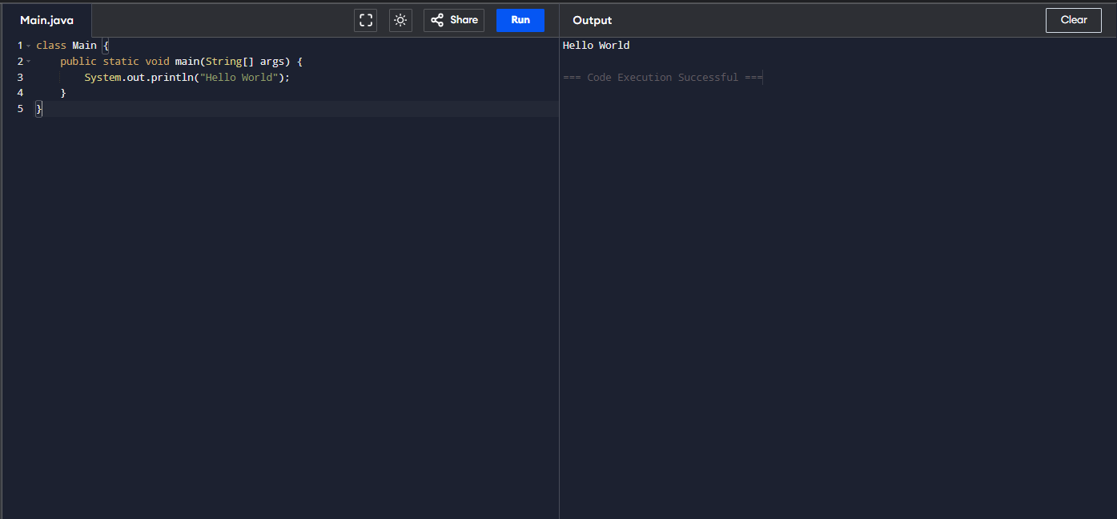

* Java Program to take input from user and print the sum of two numbers

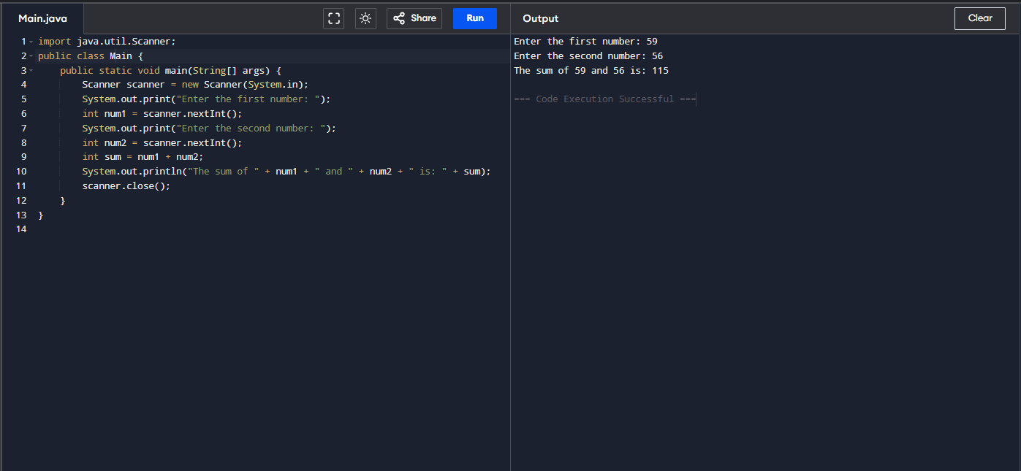

* Create a java program to check whether a number entered by user is even or Odd

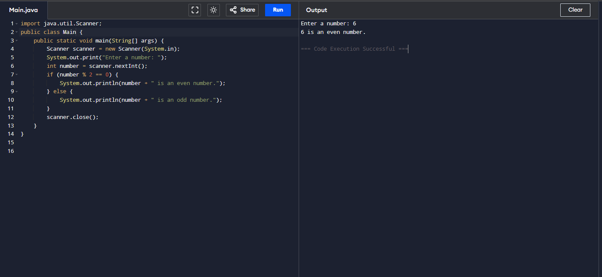

* Create a java program to print the average and sum of 5 numbers entered by user.

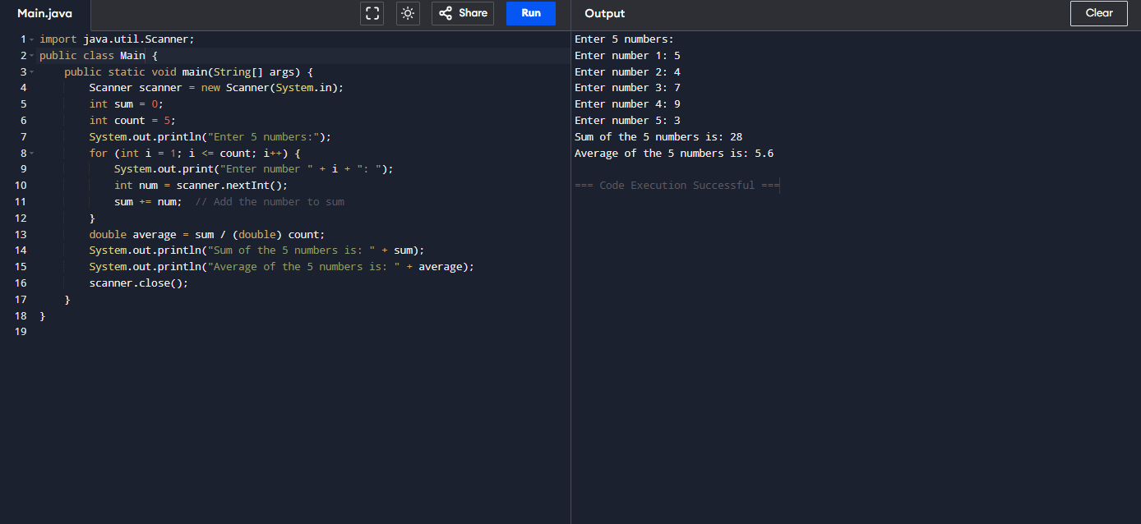

* Program to calculate the factorial of a number

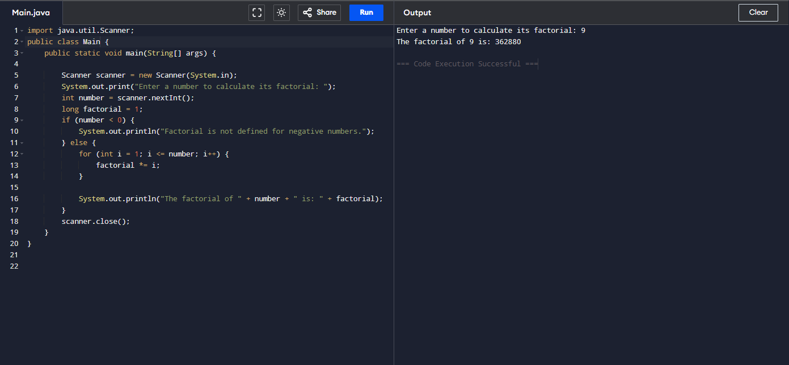

* Program to print Fibonacci series up to n terms

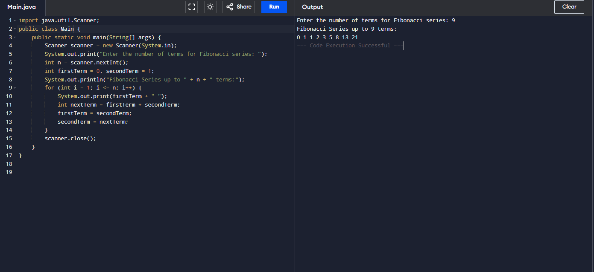

* Program to reverse a number

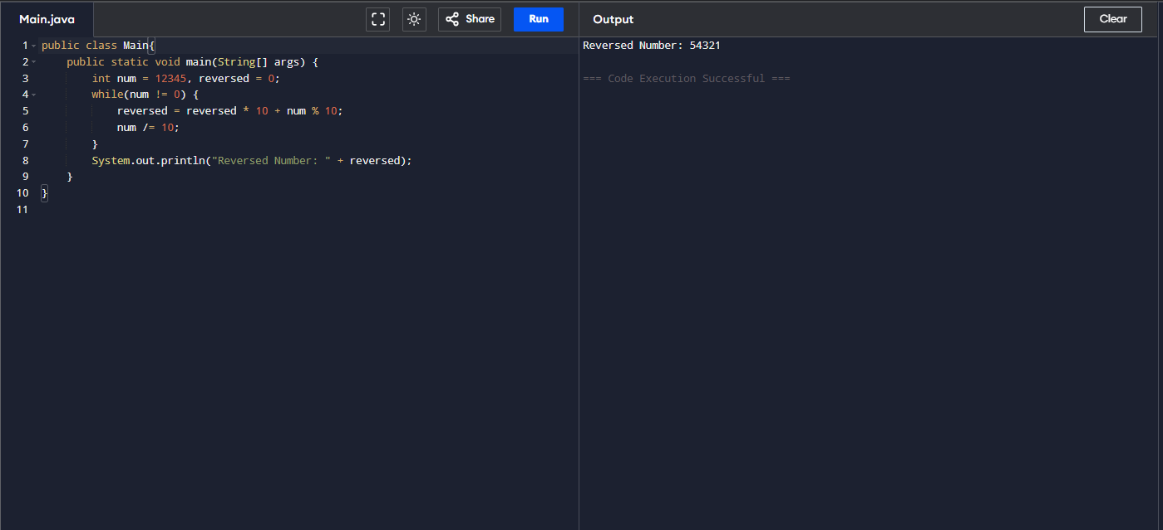

* Program to check if a number is a palindrome

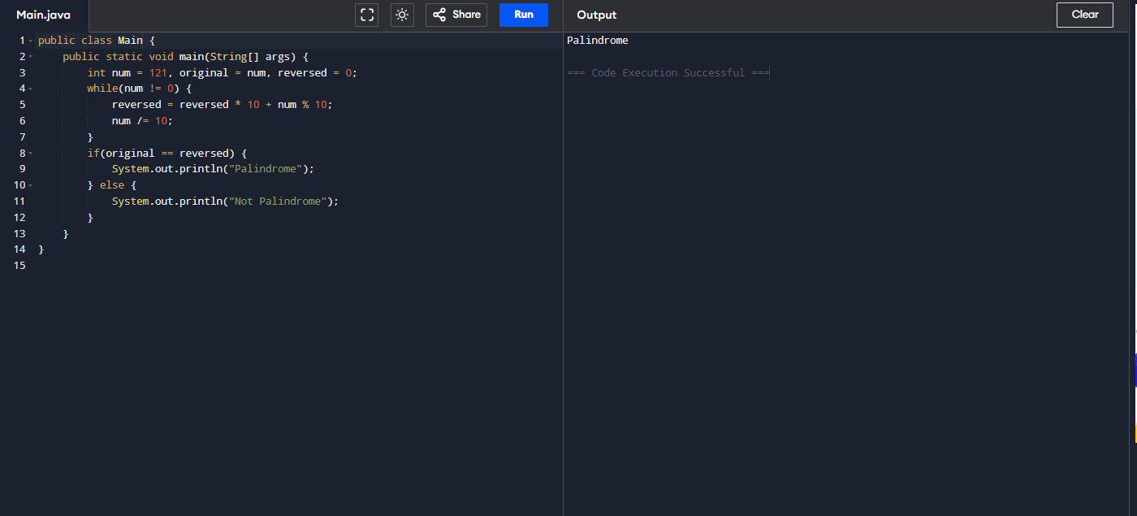

* Program for a simple calculator

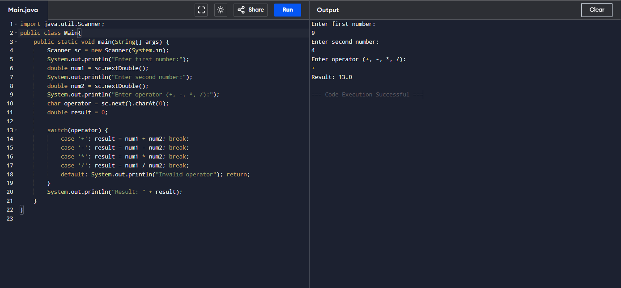

* Program to check if a number is prime

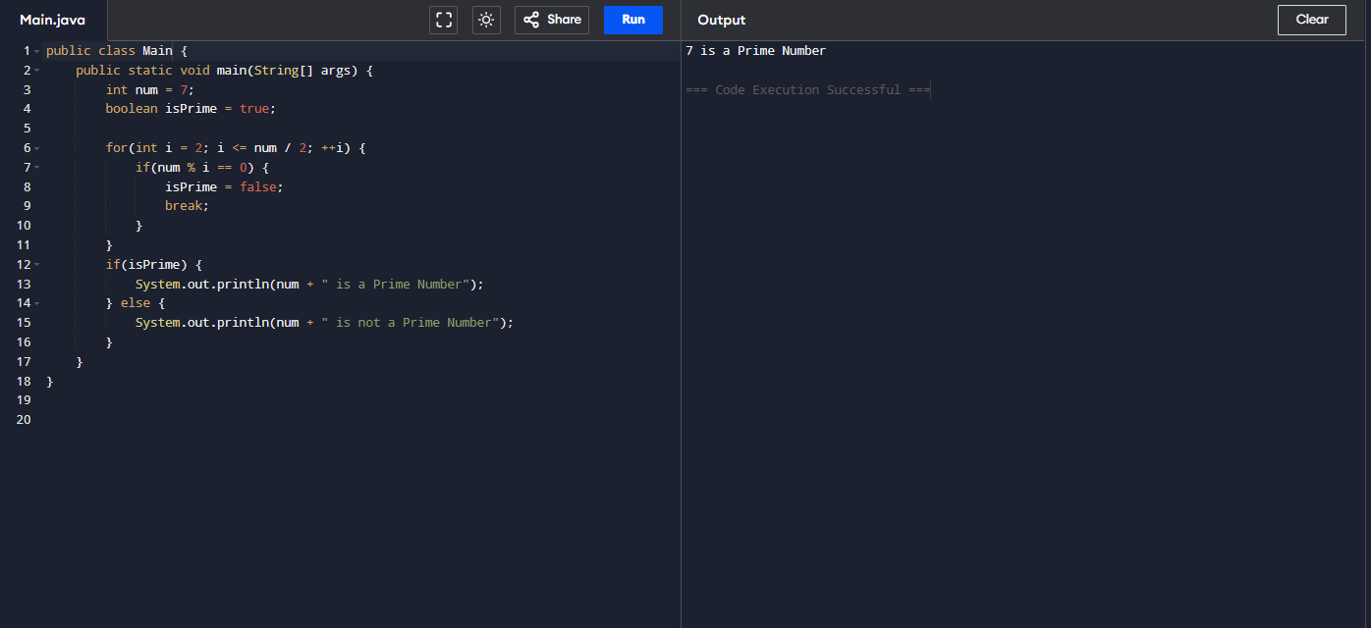

* Program to check if a number is an Armstrong number

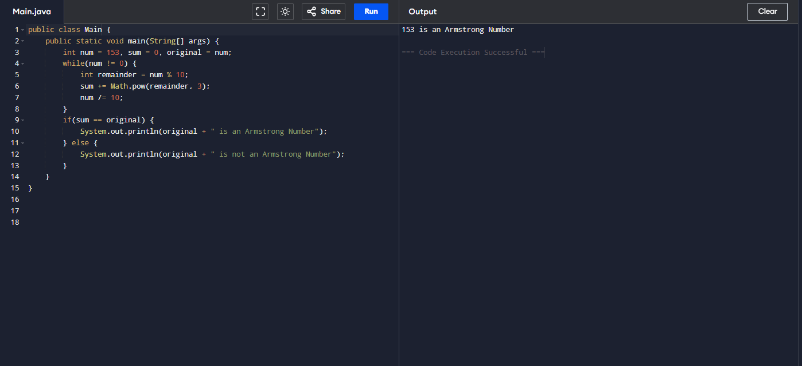

* Find the Largest of Three Numbers using ternary operator

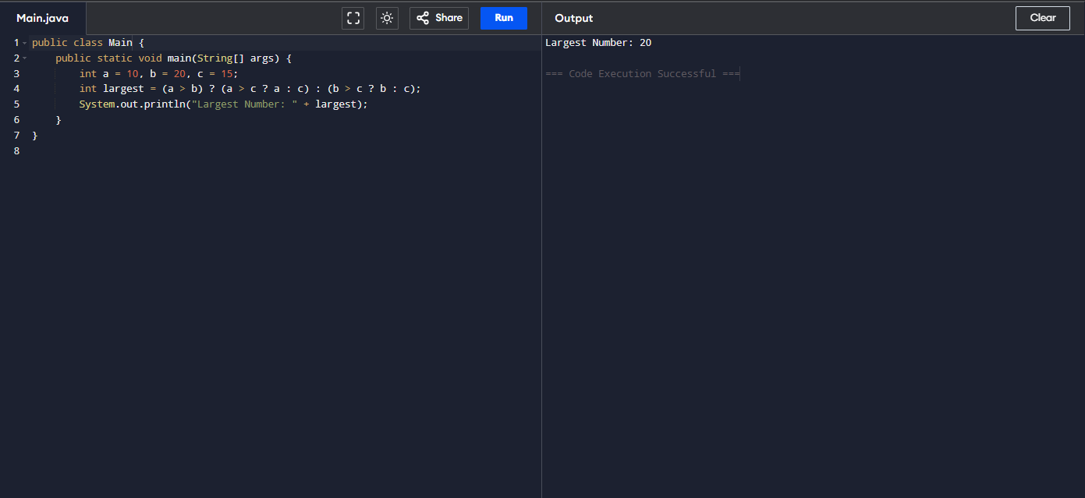

* Print Multiplication Table

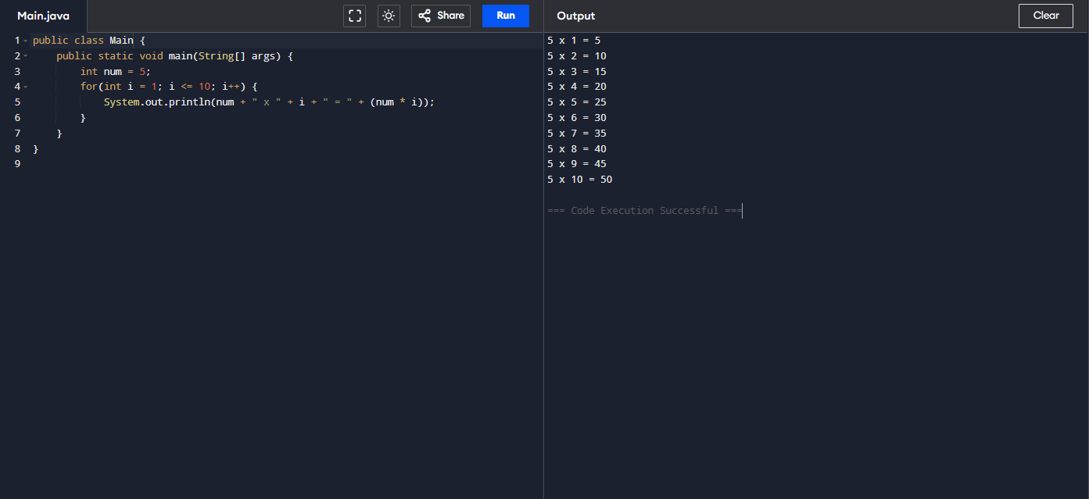

* Calculate Sum and Average of Array Elements

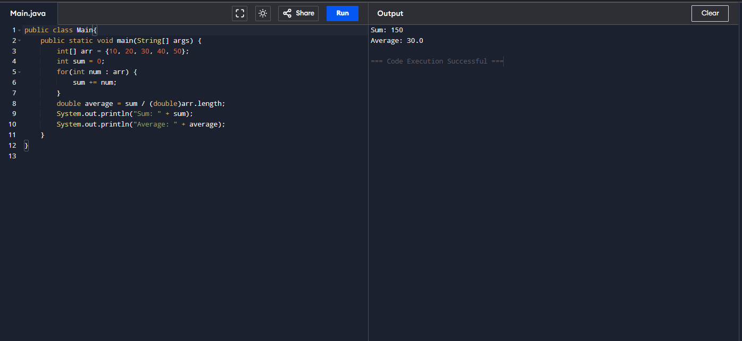

* Reverse a String

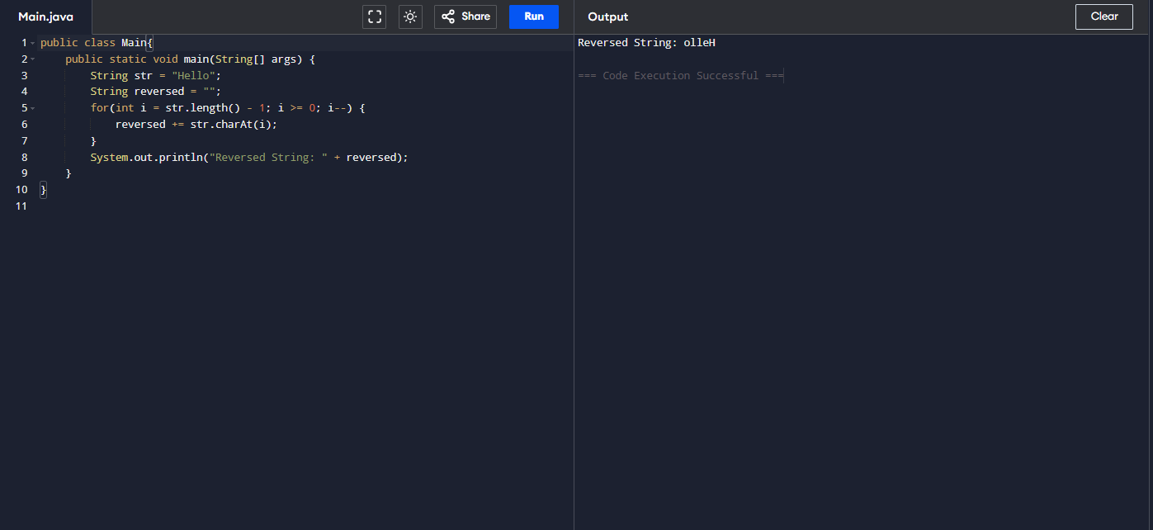

* Find Factorial of a Number Using Recursion

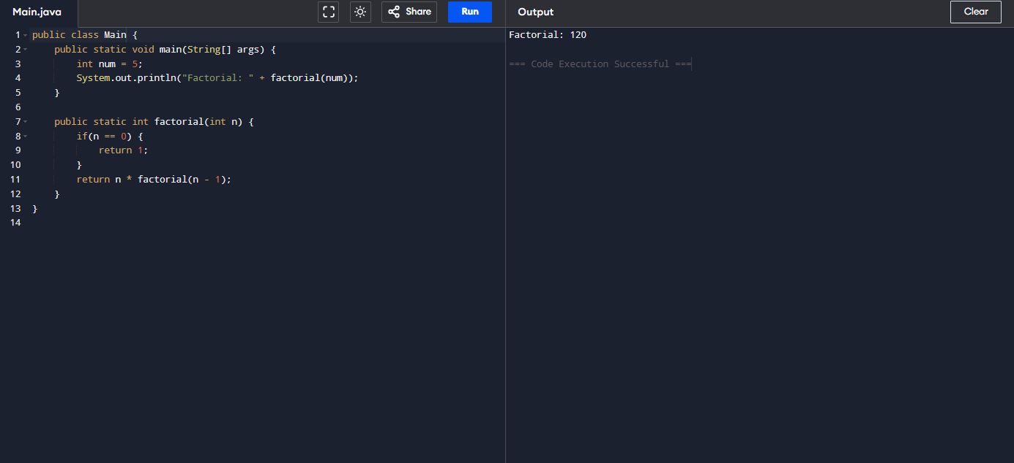

* Sort an Array in Ascending Order:

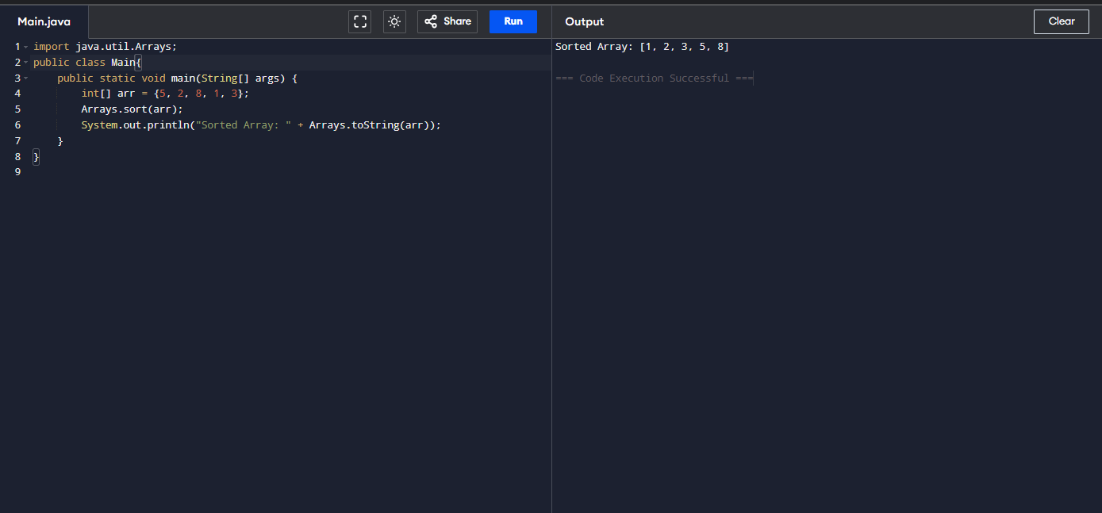

* Check Palindrome for a String

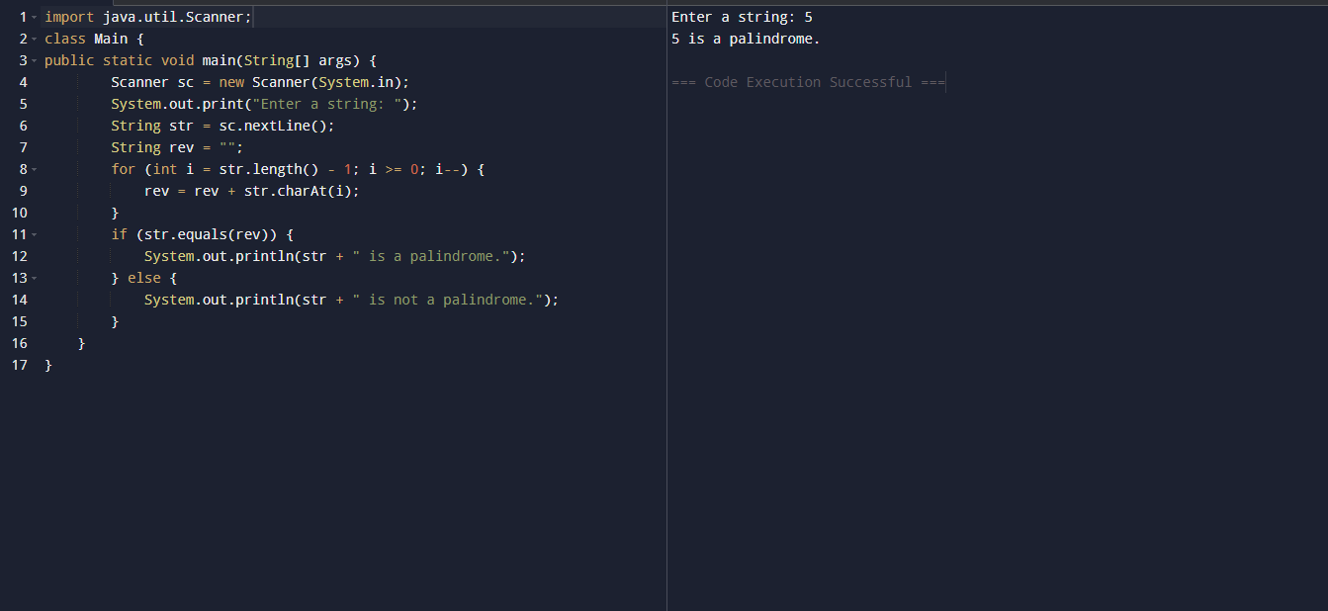

* Count Vowels and Consonants in a String

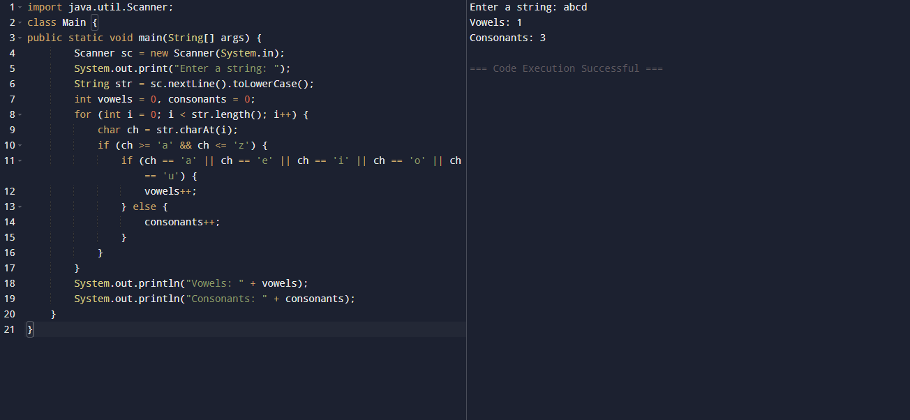

* Program to Demonstrate Type Casting

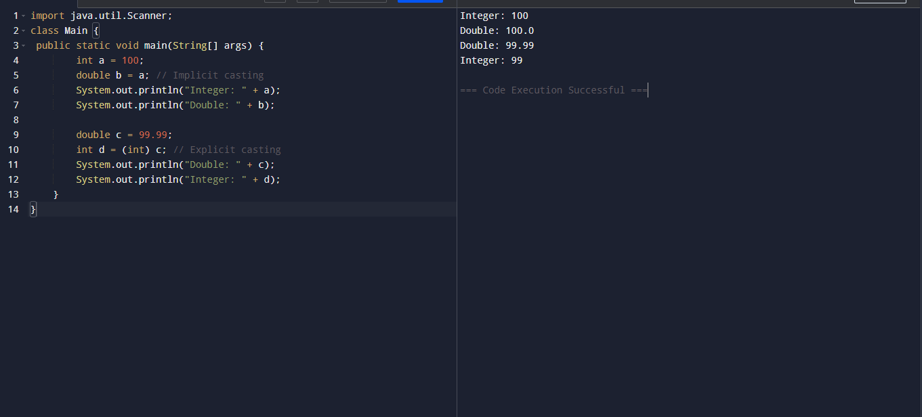

* Generate Prime Numbers Between 1 and Given Number

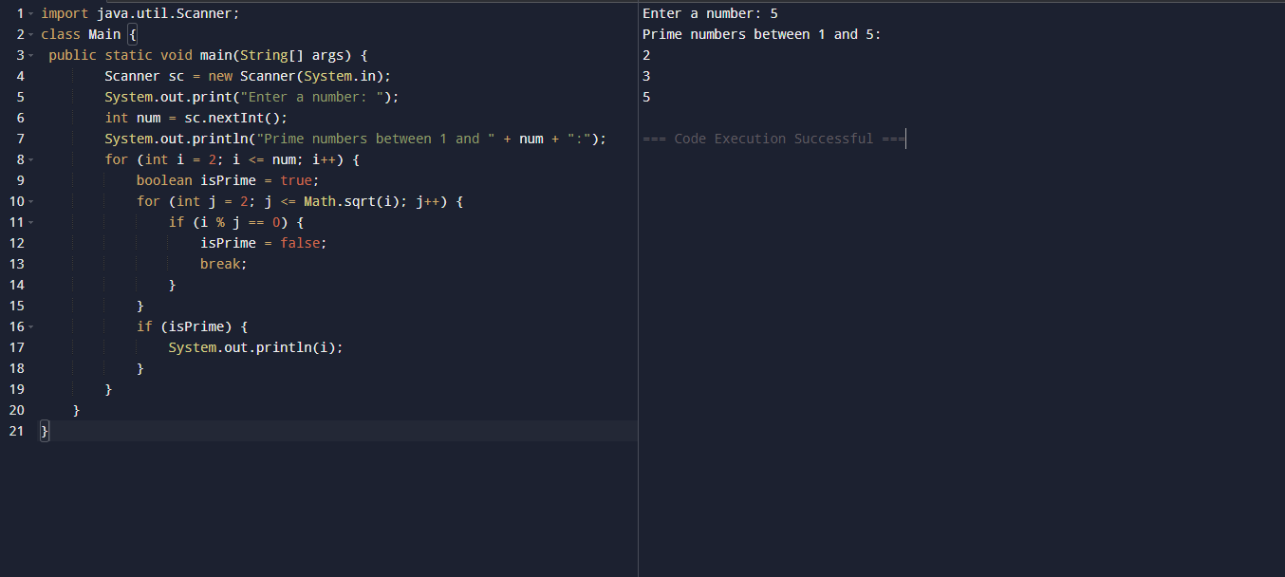

* Program to Demonstrate a Simple Class with Methods

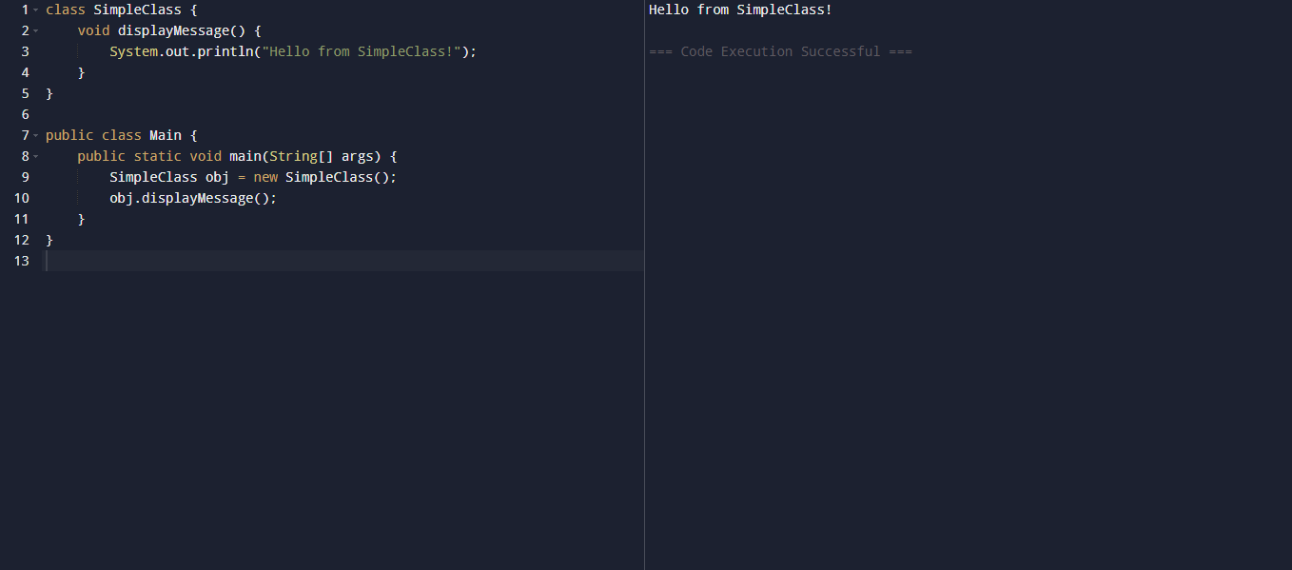

* Program for Class with Parameterized Constructor

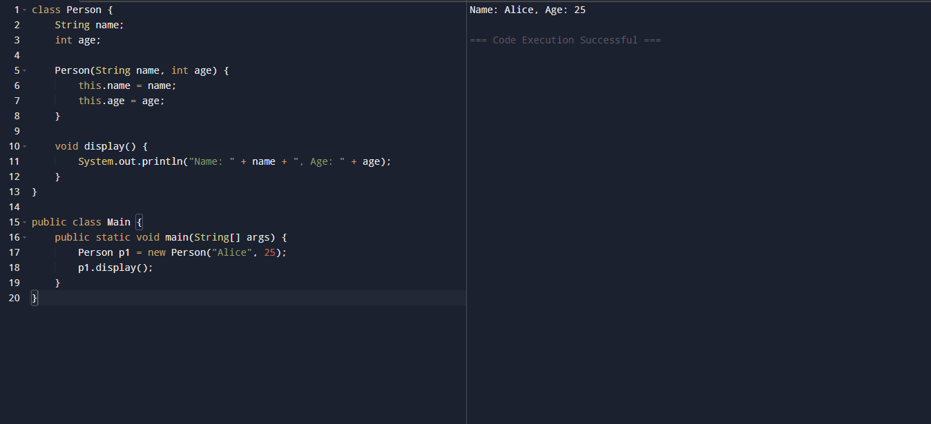

* Program to Find the Area of a Rectangle Using Methods

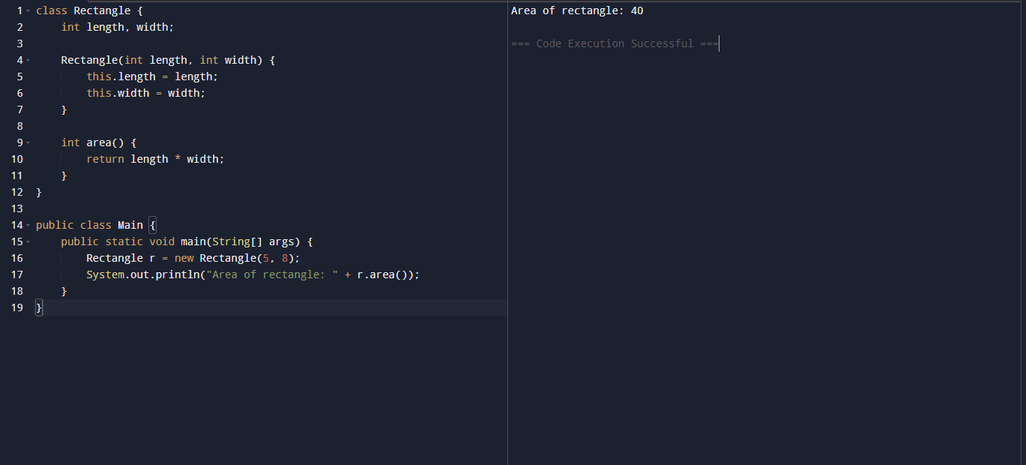

* Program for Bank Account Class with Deposit and Withdraw Methods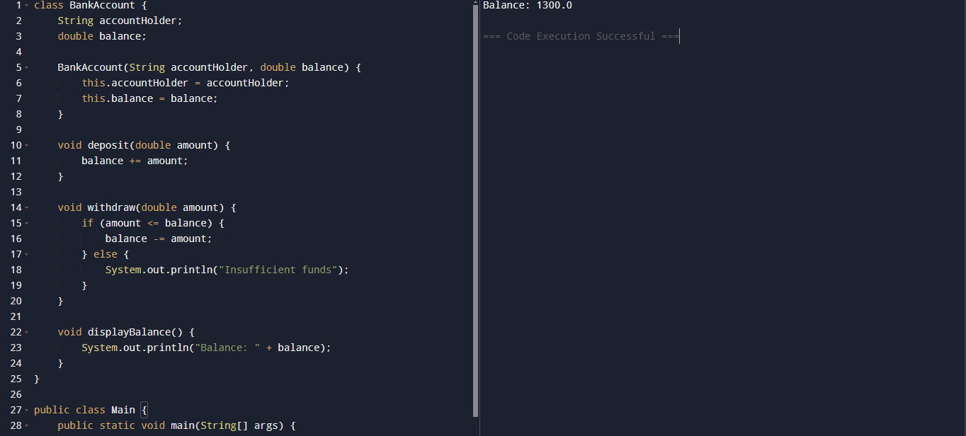 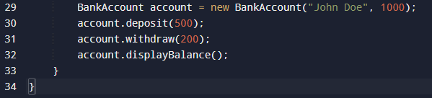
* Program to Demonstrate Method Overloading

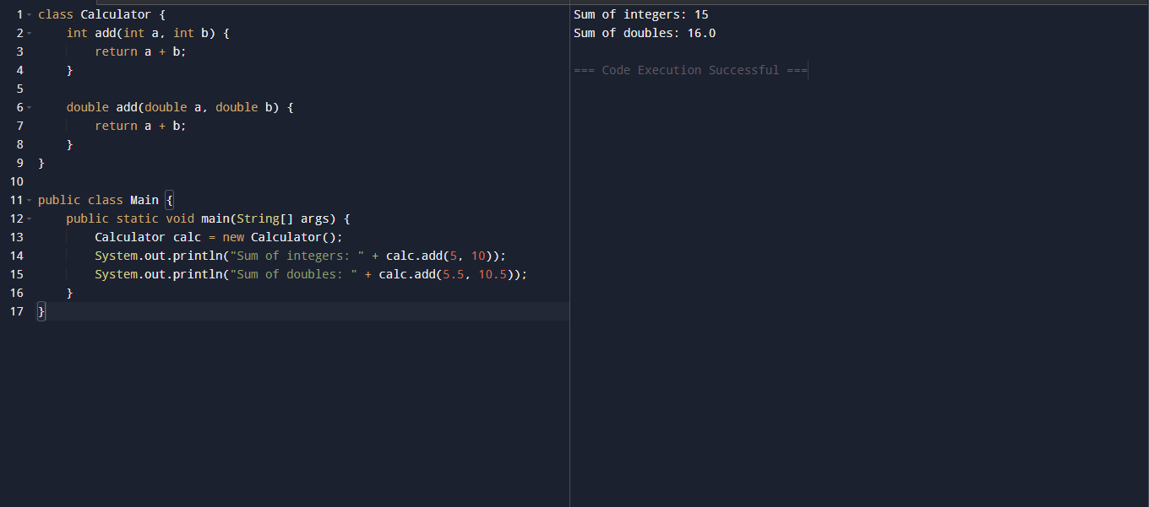

* Program to Demonstrate static methods

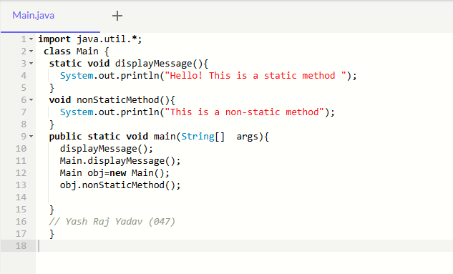

* **Output**

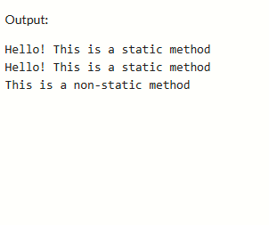

* Program To Demonstrate Method Overriding

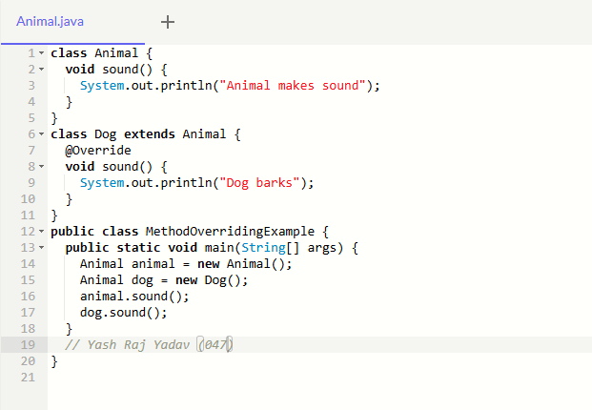

* **Output**

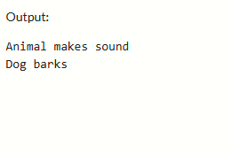

* Program to Demonstrate Getters and Setters

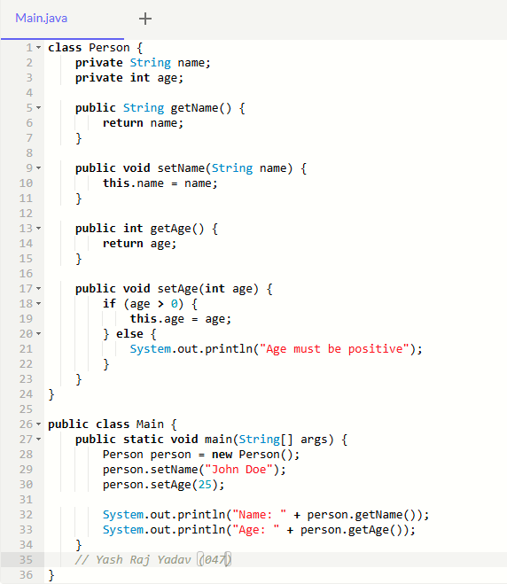

* **Output**

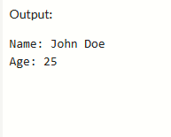

* Write a Java program demonstrating String methods like Substring(), Replace(), and Split()

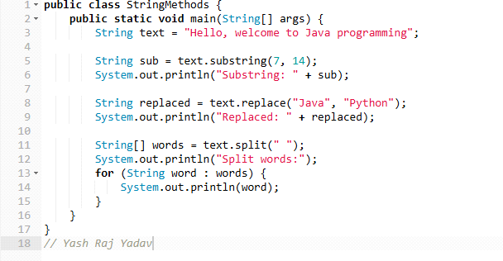

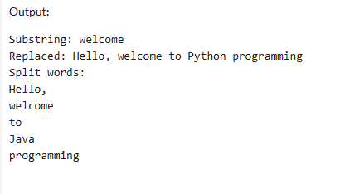

* Create a custom exception AgeException that checks if a person age is valid (above 18) in java

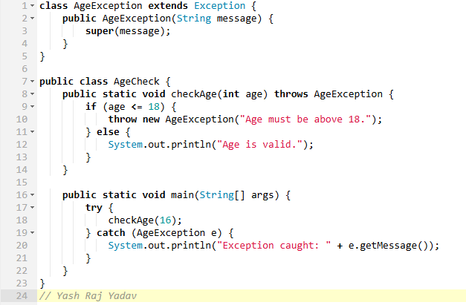

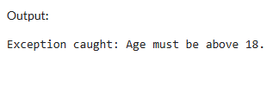

* Create a Java program that demonstrates various string functions and string handling techniques in Java. This program includes common operations like: Length of a string, Concatenation, Character extraction, Substring, Searching, String comparison, Changing case, Trimming, Replacing, Splitting

